# Project Description – Fridge Chef

# Project Aim

Our team had 2 goals in mind when creating this project, the first one was to make something that allows users to reduce food wastage and the second was to give them a platform where they can share different recipes with others.

The aim of this project is to provide a variety of recipes depending on the food stock of the user in their ‘virtual fridge.’ All the user needs to do is input their food stock and Fridge Chef handles the rest by checking the ingredients in relation to the database recipes and displays them to the user. Our app will have another type of user called a ProUser, which is people who want to share their ideas/recipes with others and many of the recipes in the database will be user-generated. Users will be able to browse through recipes created by ProUsers, add recipes to a “favorites” list and follow other users.

# Target Audience

This project is not being developed by a particular person's request, rather it’s intended to be an “off the shelf” application that any customer can utilize rather than a bespoke one. Examples of users include: students, people looking to prevent food waste, families wanting to save time when deciding what to eat and people who don’t know what to cook with items they already have.

# Essential Application Features

Essential ‘must’ - Unique Features

* Keep a virtual fridge that keeps track of items in the fridge.
* Deducts ingredients from ‘virtual fridge’ based on recipes you cook.
* Recipes based off items you have in the fridge – refined by:
  + recipes based on dietary restrictions.
  + recipes based off time of day.
  + recipes based on number of people needed to cook for.
  + Suggest recipes based on time they have available to cook.
* Users will be able to add their own recipes to the app and these will be viewable by everyone to build out the app’s recipe base.
* Allow users to plan out recipes for the next week and build a shopping list of ingredients around this.
* Have a search bar that just lets users look ant recipes regardless of ingredients in fridge.

# Desirable Application Features

Potential ‘could’ features

* Suggest healthier alternatives to the items already in the fridge.
* Tell user’s where to get certain items when they are running out based on location or cost.
* Introduce recipes restricted by budget for the meal.
* Give users warning of food going out of date – based on average lifespan of products and date when it was bought and suggest recipes from this.
* Have a family favourites section allowing users to quickly see their most like recipes.
* Have search results refined by how likely they are to like the recipe based on previous recipes they’ve eaten and what other people also liked.
* Add social functions to recipes allowing users to review recipes on the platform and allow users to refine by highest rated recipe.

# System Boundary Diagram

# User Views

In our program, the main users will be the ‘customers’ that download our application. We have split these users into users and pro-users, pro-users only differentiating by being able to add their own recipes.

There may also potentially be an admin/support user which moderates the site. The functional requirements being that they should be able to see all recipes in our database, they should be able to remove users (who spam post for example), they should be able to remove recipes (those that may violate guidelines). The non-functional requirements should be that they should be authenticated each time when logging in providing unique employee details such as their ID. The admins page should be coded in the Java programming language and the password should be between 6 to 20 alphanumeric characters including at least one higher-case letter, number and lowercase letter.

# Transaction Requirements

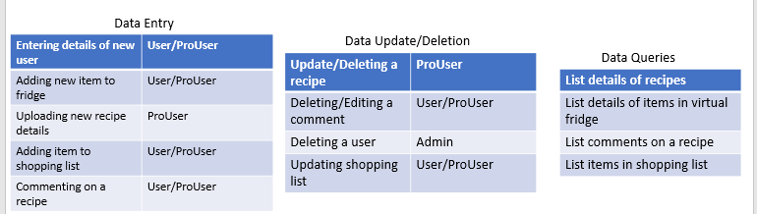

# User Views – ProUser



# Project Plan and Context

**Background Research**

* Problem 1: Understanding how to create an android app using Java – In order to understand how to tackle this problem we have identified the solution of using Android Studio. Now we have the task of learning how this software works and will do this by following the tutorials on the android development site.[1]
* Problem 2: How to store data on recipes – for this issue we have found that we will use ‘MySQL’ to write data on recipes to the database and retrieve them again. Now for the next phase we will need to understand how this functions in relation to our program, so the design of each of our ‘program modules’ is appropriate. We will be reading a referenced tutorial online to understand the basics of this concept.[2]

## Data Required

Primarily, for the project we have decided that data will be dynamically generated by user suggested recipes. We will be using BBC recipes to provide a baseline for our data and we have chosen this due to the formatting being easy to incorporate into the database.[3]

## Design Stage

For the design method, the team has decided to use object-oriented design principles. For example, this will involve taking the crucial functions of the system taken from our user views and functional requirements and then splitting these into ‘modules’ which will be coded independently of one another but still keeping in mind each modules interactions with one another (based of the system-boundary diagram)

The design documentation will include the following: Use-case diagrams, object descriptions, interface design, pseudo-code for each module, interaction chart and module evaluation criteria.

## Implementation Stage

The hardware that will be used to implement the project will be a traditional PC and it will be developed on Windows using a Java IDE and also the Android Studio platform.

In terms of the testing, each module will be tested individually according to the criteria specified in the module evaluation section in our design document. For example, this will include testing for correct, boundary and extreme cases of data input.

# Risk Assessment

## Major challenges in carrying out the project

* Communication - it’s important that communication is constant, so we end up with a high-quality project being completed on time.
* Consistency - this is vital because people will be tasked with going off and completing work independently and if their idea of the project differs from everyone else’s their work won’t fit in or well end up with a mixed match project.
* Version control – this is needed as different teams will be going off developing different parts of the system at different times. So, it’s important that this is well documented so we can bring the project together harmoniously.

## New Skills that will be required

* Android Studio – As a team we are not experienced with app development in android studio and will need to learn how to use it and the features it has.
* GitHub - needed manage the project properly and be able to combine everyone’s work from different team within the project.
* Teamworking and communication - this will be paramount to this project for reasons as mentioned above, and although people will all different experience working in teams nobody will have experience on such a scale with such strict deadlines.

# Gantt Chart

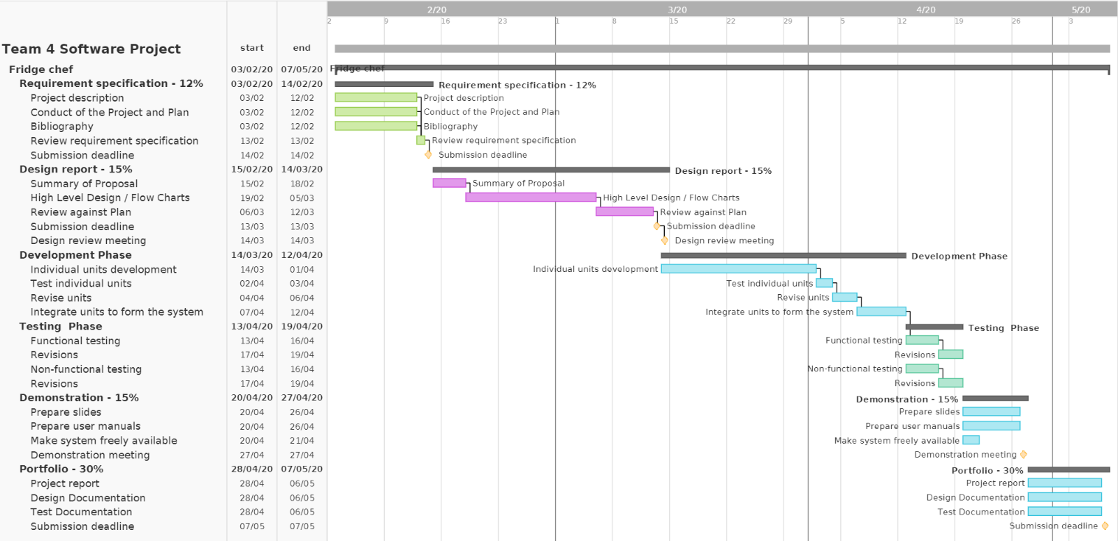

# Bibliography

Android Developers. (2020). *Build your first app | Android Developers*. [online] Available at: https://developer.android.com/training/basics/firstapp [Accessed 13 Feb. 2020].

Lars Vogel (c) 2009, 2. (2020). *MySQL and Java JDBC - Tutorial*. [online] Vogella.com. Available at: https://www.vogella.com/tutorials/MySQLJava/article.html [Accessed 13 Feb. 2020].

Bbc.co.uk. (2020). *Recipes - BBC Food*. [online] Available at: https://www.bbc.co.uk/food/recipes [Accessed 13 Feb. 2020].

1. <https://developer.android.com/training/basics/firstapp>
2. <https://www.vogella.com/tutorials/MySQLJava/article.html>
3. <https://www.bbc.co.uk/food/recipes>